Policy research paper
working document

Why people won’t take new jobs?
Policy change, household vulnerability and institutional weaknesses in the case of mine closures in Romania

Casandra Bischoff
IPF Romania Fellow
2003

Problem description

First policy to restructure the mining sector
In August 1997, in an effort to decrease the budget deficits caused by unprofitable industries, the government made the decision to restructure the mining sector, mainly by closing down unprofitable mines. In order to offset social unrest, the executive issued government ordinances such as GO 22/1997, stipulating consistent severance payments for both involuntary and voluntary redundancy. As a consequence of this ordinance, the workforce of some autonomous administrations dropped far more than the government had expected (about 15%). Thus, the restructuring of the mining sector from Romania started with uncontrolled mass lay-offs (Larionescu, Rughinis, Radulescu, 1999). In Jiu Valley, a region in the south-western part of Romania, 17,000 workers were made redundant, out of a total of 54,000 employed in the sector during August 1997 – December 1999, while other economic units in mining areas scaled down their operations, causing a sharp economic downturn.

The problems occurred as soon as the miners that had exhausted their severance packages on consumer goods found themselves lacking subsistence means altogether, in late 1998.

Second policy for mining restructuring
Acknowledging the situation that was worsening, the government contracted in 1999 a World Bank loan for mitigating the social impact of the previous restructuring policy. This program made a shift from passive labor measures like severance packages to active measures, meaning investing resources in reabsorbing the redundant population in other existing jobs or in SME programs. USD 20.78 was provided for several components like: Micro-Credit Fund for the Mining Regions; Workspace Centers and Enterprise Support Program; Employment and Training Incentives (ETIS); Public Information and Social Dialogue (PISD) sub-component; Management Information System (MIS) and Social Impact Monitoring (SIM).

Yet, socio-economic indicators of today do not show significant positive changes. The social mitigation program succeeded in hiring less than 10% of the former miners. Around 68% of the miners laid off did not find employment and some 7% of all miners who found employment have only occasional jobs (Larionescu, Radulescu, Rughinis). Both per capita and per household cash income of the local population are below the national average, more than 28% of the households cannot afford covering basic needs, while another 35% can afford only food and basic services.

Vulnerability and policy change
Given the second policy intervention the future looks grim. Agencies that are finalizing today the Mine Closure program and policy makers who are about to start new programs in the Jiu Valley deal with an environment whose main challenge is the vulnerability to falling into poverty. Repeated policy failure consumed the last resources that households had in 1997 to confront the economic crisis, and left behind a vulnerable community with little hope for better life, little cooperation and trust to support a new policy and little or no means to migrate elsewhere.

Vulnerability in Jiu Valley is an important reality to policymakers, because it is a forward-looking enemy of economic growth and policy change. Vulnerable households threaten the tax base and the economic growth. They are less likely to build new skills, to use efficiently physical assets, or to maintain social capital. They are more likely to build a poverty vicious cycle by transmitting their vulnerability to their children, who often become socially excluded and then state-assisted after they step out of the parental tutelage and they find themselves incapable of supporting themselves.

Theory demonstrates a strong correlation between high vulnerability, recovery from the event, social capital, assets, policies, and the motivation to participate in new policies. Policies imply behavior changes of the targeted population; this change needs to be facilitated not only by ensuring the policy quality, but also by providing incentives to participate in the policy. Vulnerable households are not likely to get involved in high risk/high return activities like starting a new business.

Besides building safety nets, the state has several options for strengthening the resilience of households in front of reform changes. Clear and accurate information before making the changes is a first step. Experiences in other countries have shown that the households more exposed to information and to the plans of the government were the ones that dealt with reform changes better. Secondly, involving the “beneficiaries” of the planned change in designing the change themselves is essential for improved resilience.

Literature review and research design

The theoretical background of the paper is built on inter-disciplinary associations between poverty, policy, good governance, and institutionalism literature. This eclectic approach is given by the complexity of the problem studied.

Vulnerability
There is a difference between poverty and vulnerability. Poverty is the ‘”lack of material resources, especially income, necessary to participate in the society” (Walker and Walker, 1997), while vulnerability is defined as ex-ante poverty, forward-looking and warning about potential future poverty (Stefan Dercon, 2001).

As an organizing framework, the vulnerability chain is decomposed into several components:
a) the risk, or risky events,
b) the options for managing risk, or the risk responses, and
c) the outcome in terms of welfare loss.
(Alwang, Jorgensen, 2001).

The risk can be spontaneous climatic changes but also man-made, as shown below:

Table 1: Sources and forms of risk

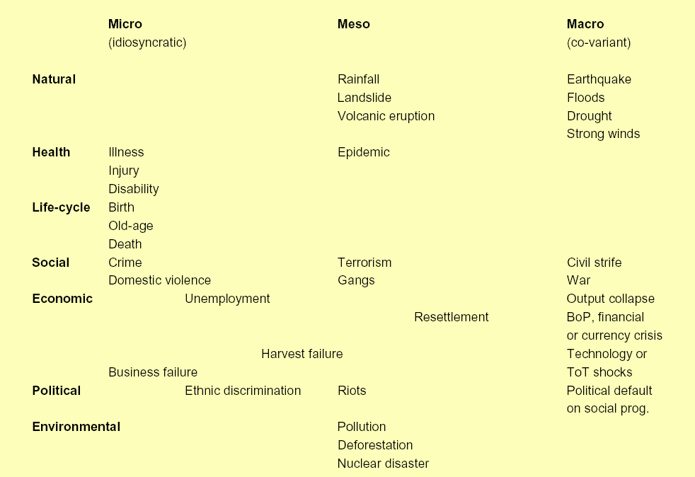

Source: Holzmann, Robert. Protecting the vulnerable: The Design and Implementation of Effective Safety Nets. 2001: Washington DC

Households can respond to, or manage, risks either by undertaking ex ante and ex post risk management actions. Ex ante actions are taken before a risky event takes place, while ex post management takes place after its realization. Ex ante risk actions can reduce risk or lower exposure to risks, such as self-insurance or savings, building social networks, and formal insurance based on expansion of the risk pool. Ex post risk coping activities are responses that take place after a risky event is realized and can involve selling assets, removing children from school, migration, seeking temporary employment, etc.

Risk, combined with the household responses, lead to the outcome. Thus, the household is said to be vulnerable from the risk or vulnerable to an outcome. The magnitude, timing and history of risks and risk responses help determine the outcome. (Holzmann and Jorgensen, 1999; 2000; Siegel and Alwang, 1999).

A socially accepted minimum must be agreed on for measuring the risk outcome. For vulnerability to consumption poverty, for example, the poverty line is usually used. While losses ex post can be measured - such as welfare lost, levels of consumption below a poverty line, loss of assets and their value, increased malnutrition, suffering from physical violence, etc - these are only the static outcomes of a continuous process of risk and response. Vulnerability is the continuous forward-looking state of expected outcomes. Ex post welfare losses are neither necessary nor sufficient for the existence of vulnerability.

Another important concept in the literature of vulnerability is resilience. Household resilience designates the ability to resist downward pressures and ability to recover from a shock, such as industrial restructuring. Resilience depends on, among other things, the effectiveness of the risk response and the capability to respond in the future.

More often than not, households face a series of constraints that prevents them from undertaking efficient risk management practices. Constraints can be asymmetric information, incomplete or missing financial and insurance markets, cognitive failures in the assessment of risks, the inability of informal mitigation efforts due to covariate risks, or exclusion from social networks (Holzmann and Jorgensen, 1999; 2000).

Governments can help households manage risks at any part of the chain. Usually the support from the government is identified in the form of safety nets, such as public works programs and food aid. However, sometimes safety nets are not well targeted to cover the whole vulnerable group, or the program has problems at the implementation stage.

Policy processes and vulnerability
Other constraints to manage risk effectively are explained by the institutional and policy literature. While awareness grows about the interface role of the institutions between the policy makers and the beneficiaries of the policies, policy processes are also looked at more and more, from the perspective of involving the beneficiaries directly in articulating the policy options themselves.

UNDP acknowledges the relationship between policy processes, institutions and social benefits: “the experience of the CEE and CIS countries suggests that the democratization agenda proceeds most smoothly and with lower social costs when changes in the role and tasks of the state are accompanied by multifaceted, systemic reforms of governance systems.” (UNDP report, 2002). It is also widely recognized that there is a positive correlation to the use of participatory approaches to policy-making and the impact of policies on levels of human development, provided participation is managed effectively.

In the view of UNDP policy dialogue means not only an exchange of opinions but also the formulation of an agreed position and approach, and the matching of different, even conflicting, interests of diverse social groups. Such procedures represent a process of communication between the institutions of power and the citizens of a country. This guarantees better the success of policies than the traditionally respected democratic institutions. The existence of democratic institutions does not imply that the process reaches its goals optimally. An effectively functioning system of authorities vested with power and governance responsibilities needs to include procedures of involving the population in the process of taking and implementing decisions. Eventually, this is good governance.

These are the perspectives from which the research expects that a strong relationship exists between the resilience of households in front of difficult reform measures and policy processes that encourage the participation of beneficiaries in deciding the configuration of those measures.

Research design
The study is conceived mainly as a qualitative study in which survey data will be collected on two main areas: 1) household vulnerability and coping strategies for economic crisis, and 2) capacity of local government and local agencies that implement the restructuring agenda of the government.

The objectives of the project are two-pronged:
- Policy demand: To identify the factors that increase or weaken household resilience in areas affected by mine closures, and to map the policy demand
- Policy supply: Identify those factors that hinder or support the policy supply at the local level
And, finally, make recommendations for policy makers active in the region, recommendations that would help both increase the quality of the programs implemented as well as the participation of the community in the respective policies.

The dependant variable is vulnerability. There are a few problems with the concept, still under construction. Practitioners from different disciplines use alternative meanings and concepts of vulnerability, which, in turn, have led to diverse methods of measuring it. Differences in approaches to vulnerability among the disciplines (sociology, anthropology, disaster management, environmental science, and health/nutrition) are explained by the focus on different components of risk, household responses to risk and welfare outcomes. (Alwang, Jorgensen, 2001).

As mentioned before, risk, combined with the household responses, lead to the outcome. Thus, the household is said to be vulnerable to an outcome. For the purpose of this research, I will use the outcome to poverty as a proxy for vulnerability. Outcome will be measured by the using the poverty line as a benchmark.

Predictors for the dependant variables can be classified in several groups:

1. Situational statistics like years spent in school (EDU) and income (INC) can be collected from the last census and from local authorities or by questionnaire.

2. Assets include tangible goods like land, labor, capital, savings (natural, human, physical and financial assets), while intangible assets will include social, institutional and political relationships, physical and social infrastructure, and location. I will make the final choice upon data availability clarifications. (ASSETS)

3. Risk responses refer to the way households respond to, or manage, risks. I will divide the variable risk responses in the two categories mentioned, ex ante and ex post actions. EX ANTE variables can be savings, new family member employed, increase in labor hours. EX POST can be loans, migration, assets selling, withdrawing children from school, disconnecting from public services like water, becoming state-assisted, etc.

4. Policy variables will include the policies as perceived or evaluated by the beneficiaries:
- Participation in the decision-making process of the restructuring (PART)
- Participation in the government programs for reinsertion in the labor market (classified by training session, consulting for inception of new business, start up) (SAFETY PART)
- Satisfaction with the information provided (INFO)
- Good understanding of the consequence of the response (measure by satisfaction with the decision made in the past, if applicable) (COGNITIV)

Data will be collected in two phases:
- Focus group facilitation – qualitative data will be collected in order to get an image about what kind of risk response miners had, why they had them and what were the factors influencing those responses.
- Questionnaire design and implementation on a group of 100 households in order to collect quantitative data about response to the restructuring policy started in 1997. Households will be selected randomly from the lists of the County Agency for Labor Absorption and the Company of Coal in Petrosani.

II. Policy implementers – institutions
Second part of the research will consist of semi-structured interviews with institutions involved in the policy process in Jiu Valley, in order to identify the constraints in implementing the policies, as they were designed. This will form a good image of the institutional blockages that can have an impact on maintaining or increasing the vulnerability of households in front of restructuring programs. Around 10 institutions sampled purposefully will be considered, using the selection criterion such as representativity of policy stakeholder groups.

Research findings

Coming soon…
Bibliography

Alwang Jeffrey, Jorgensen Paul B. Siegel (2001). Vulnerability: a view from different disciplines. Washington DC: The World Bank.

(2001) Policy process reform: Institutionalization of consultations between government institutions and non-government organizations in the CIS countries. Conditions, forms, practice: Bratislava, Slovakia

Dercon, Stefan (2001). Assessing vulnerability to poverty. Oxford University

Holzmann , Jorgensen, 1999; 2000
Siegel and Alwang, 1999

According to the vice-president of ANDIPRZM; interview taken in July 9

